NAPIER UNIVERSITY SCHOOL of COMPUTING

Systems and Services

Unit 10

Filestores

General Considerations

and

Specific Organisations

Student Study Material

• Alastair Soutar •
• Alastair Soutar • School of Computing • Napier University • Edinburgh •

First published by Napier University, Edinburgh, Scotland © 2008.
No part of this publication may be reproduced, stored in a retrieval system or transmitted in any form or by any means – electronic, electrostatic, magnetic tape, mechanical, photocopying, recording or otherwise – without permission in writing from Napier University, 219 Colinton Road, Edinburgh, EH14 1DJ, Scotland

Overview
This unit introduces the concept of Filestores within the context of an Operating System. The structure and function of a File Management System is established and then the nature of disk storage is introduced. The concepts of File Allocation Tables and Index Nodes as techniques of organising files are discussed in some detail.

Some common operating systems are studied to show these concepts in practice.

Learning Outcomes

On completion of this unit you should understand :

- Understand the structure and functions of a File Management sub-system

- Understand and appraise mapping of logical file systems to physical storage.

- Understand the principles of disk storage hardware.

- Understand how common operating systems store information on disk.

Resources Required

Documentation

Course Notes

Additional Material

Tutorial : File Management

Learning Outcome
On completion of this tutorial you should understand the principles of the organisation of a file management system, the techniques available for organising files in common types of operating systems and accessing files.

Use the unit course notes as a reference model when answering the following :

1. Describe the function of the components of a file management system.

2. Define the formula for access time for a disk system.

3. Explain the meaning of the components in the formula in Question 2
above.

4. Explain what is meant by a CHS address on a disk.

5. Describe the following disk access algorithms
(i) FCFS.
(ii) SSN.
(111) Elevator.

6. Outline the FAT technique for allocating blocks to a file on disk.

7. Outline the I-node technique for allocating blocks to files on a disk.

Practical :

There is no practical associated with this unit. However, the practical within the Linux units concerning files and directories should be used to re-inforce the concepts in this unit.

The File Management Sub-system

File Management Functions

Users perceive “data” in some application-oriented structure of files and folders (or directories). Associated with those structures are functional requirements such as operations for reading, writing, copying, controlling access etc. These logical structures and their operations do not distinguish between different types of physical storage media (except for obvious restrictions e.g. CD-ROMs are read-only).

The physical storage system includes devices and their media, such as:
Magnetic disk storage (e.g. hard disk and floppy disk),
Optical and Magneto-optical devices (e.g. CD, CDW, CDRW, DVD, Minidisk).
Magnetic tape devices (e.g. DAT, Ditto etc), and,
Semiconductor devices (memory sticks, flash cards etc.).

The user’s view of a file must be the same, regardless of the medium. For example, it is possible to create a Word document on a hard disk, copy it to a CD, then to a floppy disk. However, the logical file must remain the same, even although all three physical media use different technology to store and retrieve information, and the physical representations of the file on the media are different.

The operations are made available to the user and the system by the file manager and include:
Referencing (reading or writing) files and their contents using symbolic names; that is, data can be accessed through a symbolic view of the file store, i.e. through trees of folders (directories) and files, then records with names specified by the user. Mapping from symbolic to physical names is performed by the File manager. Files may be moved around on the disk surface in order to optimise performance without any changes to applications (except location details like drive letters). For example, the user’s perception of a group of folders or files in “Explorer” does not change if the group is moved from a floppy to a hard drive, or if a drive is defragmented, whereas, the physical layout on the disks may change entirely.
Creating and deleting files and directories.
Organising user accounts and home directories.
Controlling access according to privileges specified.
Managing the flow of data between the processor and the disk units to ensure integrity of data on disk and correct interpretation of mappings.
Thus, “Simultaneous” requests for data from different applications don’t get mixed up and the throughput of data between disk and processor is maximised.

Mapping of user data to devices

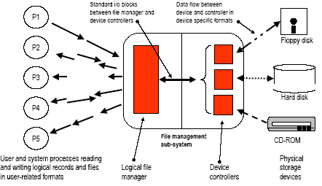

Logical file and record formats

Users work in terms of folders and files with specific purposes, for example, Reports in “Word” documents, Spreadsheets in Excel format, pictures in “jpeg” format, programs in “exe” files. These files are organised in a hierarchy of folders or directories. The hierarchy has significance to the application or the user.
Users want:
to create, delete and move folders,
to run programs contained in the folders, and,
to manage or manipulate the data contained in the files.

Ideally, the layout of folders and files, and the operations allowed should be intuitively understandable to users who know about the domain of the application.

Physical storage media formats

Each type of device is based on a technology which supports specific structures and operations. A floppy disk is similar in concept to a hard disk and is based on the same principles whilst a CD-ROM stores data, and reads data completely differently and a memory stick is totally different from both of the above.
Each type of device has a “device controller” which is designed to deal with the operation of the device, and the type of data it holds. The device controller converts between the format of the data used by the device hardware, and the internal format(s) used by the file management subsystem.
The file management sub-system converts between user or application oriented file and record formats, and interacts with the relevant device managers to store or retrieve data.

An interface is defined between the logical file manager and the device controllers. This interface implements a model which is then “imposed” on all storage devices. The interface supports standard input/output blocks each of which is identified by a logical block number. The logical blocks are distributed across the storage medium (e.g. across the surface of a disk).

Initially the blocks are unallocated in a “pool” or a list owned by the file manager. When a file is “saved” it will occupy a number of these logical blocks. As a file is extended, it will be allocated additional blocks. When a file is deleted, its blocks will be returned to the file manager’s pool.

The relationship between a logical file, and the blocks it occupies is maintained by the file manager. Individual device controllers convert between the block model and the actual storage technology used by the device. The logical aspect of files is shown below.

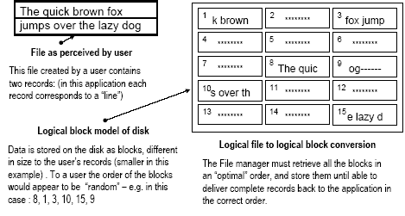
Now consider an application reading a file:
The “read” instruction causes a system call (a type of interrupt). The application blocks, and the interrupt is serviced by the Interrupt controller, which stores details of the request in a data structure. A scheduling flag is set for the File Manager.
Eventually the File Manager will be selected by the scheduler. It locates the file entry in the file index (the directory) and identifies which blocks are needed. It then translates the request into the low-level instructions needed by the disk device controller and issues these. The File Manager process then returns control to the scheduler.
The device disk controller retrieves the data from the disk and stores the blocks in a buffer area. It marks the request as done, and signals “I/O complete” for the File Manager. The interrupt causes the scheduler flag for the File Manager to be set.
When the File Manager runs, the blocks are retrieved from the buffers and assembled into the logical records needed by the application. When done, the File Manager signals “I/O complete” for the application, which causes the scheduler flag for the application to be set and the blocked process becomes “ready-to-run”.
The application will eventually be scheduled, and will start from the instruction immediately after the “read”. The logical records will be available to the process.

This process is shown in the accompanying diagram on the following page.

In some systems these signals and requests are called “events” and are managed by an intermediary called the Event manager - another Operating System subsystem.

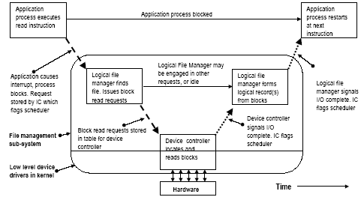

Structure of the File Manager

The File manager accepts requests from users requiring access to the file system.
It creates files by creating the directory entries.
It writes data to files by obtaining blocks from a “free pool”, packing logical record content into blocks, following the indexing structures to find the correct location for the blocks and writing them into those locations.
It extends files by allocating additional disk blocks updating the index structures and storing the additional data as described above.
It contracts or deletes files by altering/removing directory entries and returning disk blocks to the “free pool” (usually a dummy file that owns all the free blocks).
It reads data from files by following the indexing structures to find the required blocks and constructing the logical records from the blocks.

The File manager is layered like most areas of the Operating System:
The highest layer supports user-level abstractions - files of different types, some with a logical record structure, and folders (directories) inside which the files are organised.
The intermediate layer(s) accept requests from the top layer and organises them to achieve the best performance from the lower layers, then it reassembles the results.
The lowest layer “talks” directly to the specific hardware controllers for the individual storage devices. Parts of this layer are usually in the Operating System kernel.

Suppose there is an application that is required to read all of the logical records stored in a disk file. This kind of requirement would result from an application which read all of the “employee” records from a “personnel” file. The logical order of the records could be “alphabetic by employee surname”, or “employee number”. It should be borne in mind that a logical record may be larger, or smaller, than each block depending on the application, and the hardware of the disk. The physical blocks containing the records will be stored in various locations on different parts of the disk surface. The device controller will attempt to retrieve the blocks in the most economical way (the least work for the disk mechanism). This may be random from the point of view of a logical record.
Blocks have to be stored (buffered) until the logical record can be reconstructed. Logical records may have to be buffered until they can be delivered to the application in the right order.

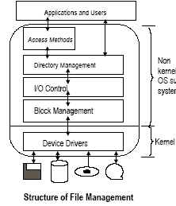

Access methods

This is an optional layer that provides ways of storing and retrieving data for applications. It may be absent altogether, or simple such as a sequential file or an indexed file, or very complex such as a corporate database management system providing data services to groups of applications.

Directory management

This provides a logical view of the storage in terms of volumes, directories and files. This is what the user or programmer sees. For
example, a pathname such as
C:\Program Files\Microsoft Office\Of97spec.ini

Input/Output Control

This routes requests and responses between the correct devices and applications.
To find the file whose pathname is C:\Program Files\Microsoft Office\Of97spec.ini, this layer will determine which physical drive is C:\, and which application asked for the file.

Low-level Block Management

This organises read/write requests into best order, issues requests to disk drivers, and buffers data in memory. For example, several processes may have requests outstanding for the C:\ drive and the best order to deal with them may not be that of arrival time.

Device Drivers

This controls the dialogues between the Operating System and the hardware device controllers. There are specific drivers for each device type (e.g. C:\ on one machine may be an EIDE device and a SCSI device on another).

Data Storage

The physical media such as hard disks, floppy disks, CD-ROMs, DVDs and tapes store information as magnetic or optical “marks” on a physical surface. These marks are not recognisable as programs or data but simply as encoded bits. The encoding methods are often complex.
Groups of marks (called blocks) can be read or written by “heads”. Blocks are the units of transfer between the hardware and the Operating System.
The head(s) can be positioned to read or write specific blocks. On magnetic disks (e.g. hard disks and floppy disks), the blocks are stored in concentric rings called tracks. Each block is addressed by the track number and the “sector”, i.e. how far round the track a particular block is physically positioned. On optical disks, the blocks are written in a continuous spiral containing the blocks. They were originally designed for storing music using mainly serial access.
The blocks making up a file will be stored anywhere on the medium. This is particularly true with magnetic disks especially after being in use for some time. Due to program requests, files are created, extended, compacted and deleted and new files fill any gaps whilst deleting a file will create gaps on the disk that can be re-used etc.
Other device types such as memory sticks use other technologies

Magnetic Disk Controller

This is the hardware which connects the kernel device driver for the magnetic disk(s) to the disk hardware. On a PC, it is normally a chip located on the motherboard. Different types exist e.g. SCSI - small computer systems interface and E-IDE - Enhanced Integrated Drive Electronics. This hardware manages the flow of data between the processor and the disk units.
Disk units may be on a shared bus, or on individual buses.
A “channel” is a small processor which controls a single disk unit.

Magnetic Disk Unit

This contains a set of circular platters rotating at high speed (normally over 5,000+ rpm), on a common spindle. The platters have a magnetic coating on the surfaces.
Read/write heads mounted on fingers move radially across the platters, just above the surfaces. Each head “sees” the surface as concentric tracks.
A “cylinder” is a set of tracks directly above/below each other, and a “sector” is an angular “wedge” of the surface. A sector is usually a hardware block.
Blocks are numbered with a logical block number (LBN), and located by their CHS address (Cylinder, Head, Sector).
Reference points are set up during formatting of the disk, so that the location of block x at cylinder p, head q, and sector s can be determined.

Organising Disk Hardware

The arrangement of the processor, disk controller and the actual disk units themselves is shown in the diagram overleaf. The disks can be connected to the controller using buses or channels.

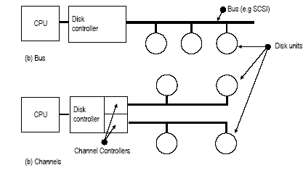

Single Disk Platter Layout
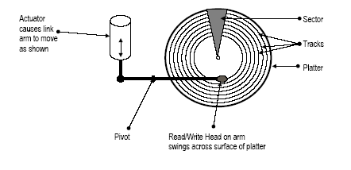

Cylinder Organisation

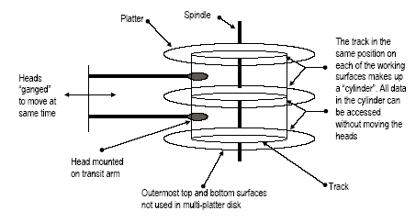

The Physical Disk

The disk hardware needs to be able to move the disk head(s) across the platter(s) from track to track to locate any physical sector in order to read or write data blocks. This operation takes a certain amount of time.
The “Access Time” is made up of the “seek time” plus the “rotational latency”.
The Seek Time is the time needed to move the head from one track to another. It comprises:
a starting delay to accelerate the head, steady movement across tracks, and a stopping delay.
A change of direction from the previous seek also increases the total time taken. The time to move across the tracks depends linearly on the number of tracks traversed i.e. to traverse ten tracks takes ten times longer than one track.
The Rotational Latency is the time spent waiting above the track for the correct sector to arrive under the read/write heads. On average, this will be one-half the rotational time. (The best case is zero, and the worst case is one full revolution, or the rotational time).
The total access time is the sum of both - typically an average of between 8-15 mSec on a modern hard disk, rotating at between 3,600 and 7,200 rpm.

The data transfer rate (KBytes/sec) is another factor to be considered in disk performance. It depends on the individual disk unit and the controller type. SCSI disks are generally faster than EIDE disks. One main reason for this is that the SCSI controller is multi-threaded, whereas the EIDE controller is not, so requests can be part completed without giving up the processor in the case of the SCSI disk.

Consecutive read/write requests may refer to totally disjoint locations, so, disks employ seek algorithms to decide the order in which to visit different locations on the disk to service these requests. The choice of algorithm has much more effect on performance than small changes in total seek-time. The aim of the more efficient algorithms is to minimise head movement, so saving time overall.

Seek Algorithms

First Come First Served (FCFS)

All requests are dealt with strictly in the order of arrival. A simple First-in, First-out queue is used to store requests. Results are sent back to the processor immediately. This algorithm is simple to implement, no buffering is required, but it is potentially very slow.

Shortest Seek Next (SSN)

Here, requests are queued and carried out so that the request causing the shortest seek movement is always done next.
This improves efficiency by servicing the “shortest” requests first.
However, in a heavily-loaded system using this algorithm, the tendency is for heads to remain near the middle of the disk and for requests at the peripheries to be queued indefinitely.

Elevator Algorithm

Here, requests are put into a queue as they arrive. A bit is set to note the direction the head was moving in when dealing with the previous request. The next closest seek in the same direction of travel is taken from the queue.
When there are no more requests in the queue in that direction to be served, the direction is reversed.
The disk head tends to move steadily across the disk in alternate directions.

These methods may deliver data in a different order from that expected by the applications and hence, individual applications have to wait for data and requests and data will need to be buffered in the block manager layer.
An address translation in the Basic Input/Output System (BIOS) between Cylinder Head Sector (CHS) and Logical Block Number (LBN) is necessary as the disk hardware uses a CHS address to locate a data block whereas Logical File Managers use a LBN scheme. This translation of CHS to LBN is usually done in the BIOS, using a table or a formula created when the disk unit is installed.

File to disk-block mapping methods

There are two different approaches: the FAT (File Allocation Table) and the I-node (Index Node) schemes will be considered to illustrate the techniques and the implications.

File Allocation Table (FAT)

A FAT is a table that has an entry for every block of data on the disk. FATs were first used for floppy disks in the CP/M operating system, and then adopted by its successor MS-DOS. The method was later extended to Windows-95, 98 and ME. Windows NT (including 2000 and XP) has its own method (NTFS) but all versions can access FAT file stores (all floppy disks still use the FAT method).

Inodes (or Index Nodes)

An inode is an index table that relates to a single file and shows which blocks are being used by that file. Inodes can be daisy-chained to provide access to very large files. That is, an inode for a file can point to further inodes, which in turn point to the data blocks of the file.
This approach has been used in many UNIX systems for 30-plus years.

Both techniques require a “root” directory to be held at a fixed physical reference point to allow the logical directory structure to be accessed.

FATs – the directory entries

In a FAT-based file system, blocks on the disk are allocated by the file manager in allocation units, or “clusters”, which may contain more than one physical block. The root directory is of a fixed size, dependent on the type of disk, and located at a known CHS address on the disk.
Other directories (i.e. except the root) are held as on the disk as files and may contain an unrestricted number of entries. The entries are used in the same way.

An example of a directory entry is shown below. Each directory entry is 32 bytes long.

The “First-cluster” is the number of the first cluster allocated to the file. Subsequent clusters can be identified from the FAT as explained later.

The “Size in Bytes” gives the actual size of the file. From this, knowing the cluster size, the number of clusters can be calculated, and the “slack” in the last cluster.

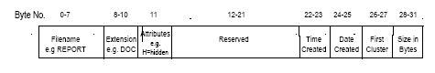

Overview of file access using a FAT

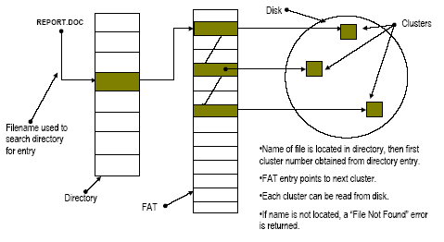

FATs

The FAT is a table with an entry for each cluster (“allocation unit”) on the disk. Each entry is indexed by the cluster number, and contains one of:
another cluster number – this is the next cluster in the chain making up a file or,
an end of file marker – there are no more clusters in the file or,
a “bad-cluster” marker for any “damaged” areas of the disk to prevent their use.

Two copies of the FAT are stored on the disk (one at the start and one at the end). If one is damaged, the other may be used for recovery. To speed access, the FAT is loaded into memory when the disk is being used.

A disk crash can leave the FAT and the disk contents out-of-step. The DOS / Windows utility “scandisk” can detect this and often recover from it.

Some clusters are reserved for system use. For example, clusters 0 and 1 are used by the system - they store the root directory and the FAT. Initially, all other clusters are in the “free list” - they form a “free space” file.
As files are created or extended or deleted:
The directory entry for each file holds the size of the file and the number of first cluster.
Clusters are allocated to the file by removing them from the free list and joining them into the chain of entries that make up the file.
If a file is deleted, its name in the directory is marked as deleted, and the clusters returned to the free list.
No data is changed in the clusters on the disk.

The contents are still available and can easily be read if the disk has not been used since the deletion. In an accidental loss this is actually an advantage. On the other hand, if the contents are confidential, it is a potential disaster waiting to happen!

For files in folders below the “root” directory, the lower level folders are held as files, and they must be “read” to locate the directory entry to gain access to the chain of cluster numbers representing the file in the FAT.
A typical FAT is shown below.

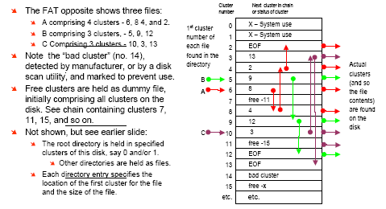

Problems with FATs

Initially, FATs were developed for small floppy disks (e.g. 128 -320KBytes) and 12 bits were allocated to a cluster number, called FAT-12 which gave a maximum of 4096 (= 2¹²) clusters.
The development of hard disks, and tree-style directories, has caused an increase to 16 bit entries, with a maximum of 65,536 = (2¹⁶⁾ clusters.
Thus, the number of clusters is fixed (by the number of bits allocated for each cluster number). If a larger disk is used, the number of clusters remains the same, but the size of each cluster must increase. The smallest file size will always be one cluster.
If the disk is larger than 64MB, the cluster size must be greater than 1KB. A 2G-Byte disk has clusters of 32KB, even for a file containing 1 Byte of data. With a large number of small files, the overall wastage is very great. 10 files, each of only 1 Byte would be allocated 320 Kbytes of disk space!
Also, integration into a distributed file-system is messy.
Win 95, 98 and Me allow use of 32-bit cluster numbers to solve some of these issues.

In use, the entire FAT is held in RAM, even if only one file is being accessed. The essence of the problem is that the order of the clusters for all files is mixed up at random in the FAT ( see Tanenbaum) and the FAT is an index to the entire disk, not to a file.

To get to the last cluster in a file requires sequential chaining through all the FAT entries belonging to that file.

Inode file structures -

The physical disk is formatted into fixed size blocks, usually quite small in size. These can be as small as 512 Bytes, but 1-KByte is more typical.
Block numbers are usually 32 bits long, so the maximum number of blocks that can be addressed is 4,294,967,296 (= 2³²). For a 1KByte block size, this would be a maximum disk size of 4 TeraBytes!

In theory, any block can be used as a primary inode, a secondary inode or a data block. In real systems, blocks tend to be grouped so that low block numbers are used for inodes and higher block numbers are used for data blocks.

Every file comprises at least a single I-node, and most will also have at least one data block.
An “empty” file (i.e. one of zero length) will have only a primary inode.
A small file will have a primary inode and some data blocks.
Larger files will have a primary inode, one or more secondary inodes and many data blocks.
All files, whether directory files or data files, are stored in exactly the same way.
As with the FAT scheme, the root directory must be stored at a known, fixed location on the disk. This is summarise in the diagram below

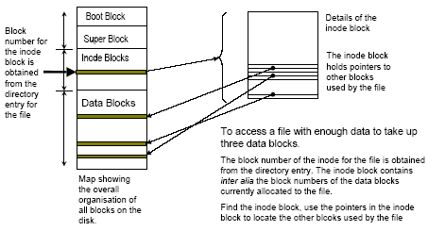

The primary inode contains “housekeeping” information and is an index to the file and typical contents are:

The file name, its owner, the group to which the user belongs, the number of bytes occupied, date created, accessed, modified, the number of links to the file.
The “housekeeping” details are followed by a list of block numbers where the data contents of the file are stored; typically there are 13 block numbers in the list.
The first 10 block numbers are direct pointers to data blocks (but need not all be present, and could be null if the file were empty)
The next three block numbers are present only in files of increasing size:
The 11th block number points to a “single indirect” block - i.e. a secondary inode, containing the numbers of any data block numbers after the tenth data block.
The 12th block number points to a “double indirect” block - i.e. a secondary inode containing the numbers of another, second level of secondary inodes.
The 13th block number points to a “triple indirect” block -i.e. a secondary inode containing the numbers of a set of secondary inodes which themselves are indexes of a third level of such secondary inodes.

If each block is identified by a 32-bit block number:
1 K-Byte blocks give a maximum file size of around 16 GBytes.
With 2 K-Byte blocks, this rises to around 28 GBytes (per file!)

Secondary inode(s) for a file will be needed only if there are more than 10 data blocks in the file.
All blocks in the file system are the same size
There are no housekeeping details in the secondary inode
The secondary inodes contain only the block numbers of other blocks.

If the block size is 1024 Bytes and the block number is 4 Bytes (32 bits), then there is room for a list of up to 256 block numbers in each secondary inode.
The secondary inode acts as an index to a set of blocks.
If one inode holds the numbers of other inodes, a “multi-level” index is created.

In UNIX the structure of a file is an “unbalanced” tree. The first few data blocks are indexed directly from the primary inode. Subsequent blocks are indexed from single, double or triple-level indexes. Each of these n-level indexes is located from the primary inode.

Structure of a file using inodes

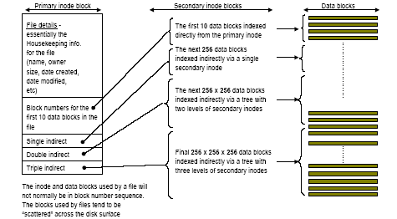

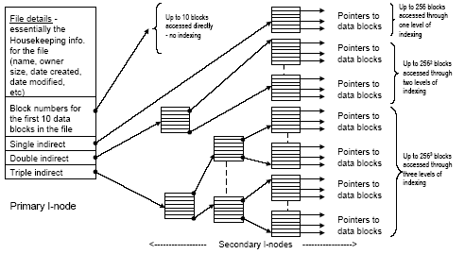

With a block size of 1Kbyte and block numbers 32-bits long:

In files up to 10KB (10 blocks of 1Kbytes,) all data blocks can be accessed directly from the primary inode.

In files up to 266KB (10 + 256 blocks of 1KBytes):
The first 10 data blocks can be accessed directly from the primary inode
The next 256 data blocks require the single indirect inode.
In files up to approximately 64 MB (266 + 256² = 65,802 blocks of 1KBytes):
The first 10 data blocks can be accessed directly from the primary inode
The next 256 data blocks require the single indirect inode.
The next 256² data blocks require two levels of indirection through the double indirect entry in the primary inode, and the 256 secondary inodes referenced by it.

In files up to approx. 16 GB (10 + 256 + 256² + 256³ = 16,843,018 blocks of 1KBytes):
The first 10 data blocks can be accessed directly from the primary inode
The next 256 data blocks require the single indirect inode.
The next 256² data blocks require two levels of indirection through the double indirect entry in the primary inode, and the 256 secondary inodes referenced by it.
The final 256³ data blocks require three levels of indirection. The triple indirect entry in the primary inode points to the 256 secondary inodes. Each of these entries points to 256 secondary inodes. Each of these 256² inode entries point to 256 data blocks

management considerations

Only those blocks needed to access the file need be in memory.
The primary inode is brought into memory when the file is opened and remains there until the file is closed.
Between one and four more disk reads will locate any block in a file;
A single data block in a small file up to
The triple indirect inode, two further secondary inodes, then a data block in a large file
It should be remembered that all names in a path are, in fact, files so the directory files in the path will also have to be opened.

However, directories are seldom larger than 10KB.

With a 1KB block size, much less space is wasted compared with the 32KB minimum block size under FAT-16 on a 2GB disk.
The minimum size of a file will be 2KB (1KB for the inode and 1KB for the data block).

Disk caching can be readily implemented whereby blocks are held in a file cache in main memory so long as they are being referenced. This greatly improves performance, and is economical if blocks are 1KB in size.
1MB provides a block cache for about 1000 blocks of 1KBytes

The directory structure in UNIX

All aspects of data storage in UNIX are based on files. Thus, every directory is a file, and every entry in a directory entry is a line (a record) of a file. All files are stored in blocks using the indexing structure using inodes shown earlier.
The minimum needed for a (non-empty) file is 2 blocks – an inode block and a data block. The maximum would be represented by the multi-level inode structure shown earlier, plus many thousands of data blocks.

A file with the pathname “/usr/ahs/tunix1.doc” uses four distinct files to form the pathname:

“/” is the root directory. One of the files contained in the root directory is another directory called “usr”.
The directory “usr” contains (amongst other things) a directory called “ahs”. One of the files in the directory “ahs” is an ordinary file called “tunix1.doc”.

Each directory entry gives the number of the primary I-node for that file. The I-node contains pointer to blocks containing “data” for that file (i.e. the directory contents).
This is illustrated in the following diagram.

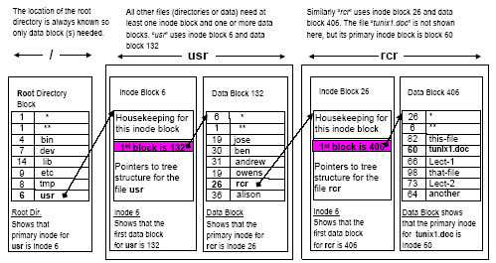

Windows NT File System (NTFS)

This is a radically different approach to file allocation, which is intended to be robust and secure.

Files are allocated as clusters which are independent of the physical sectors of the disk which allows non-standard disk types to be supported.
Files are stored on a “volume” which can be part of, all of, or several, physical disks.
The system is configured with 2^{n} sectors per cluster (n = 0, 1, 2 …7). So,
for a sector size of 512Bytes, this would give cluster sizes between 512Bytes and 64Kbytes:
512 x 2⁰ = 512 x 1 = 512Bytes; 512 x 2⁷ = 512 x 128 = 64KBytes

Large volumes use larger cluster sizes, small volumes use smaller cluster sizes.
The cluster size is decided by NT when the volume is formatted,
In practice:
For volumes between 1 and 2GBytes, the cluster size is 2 Kbytes;
A cluster size of 32 KBytes is used in volumes between 16 and 32 GBytes.

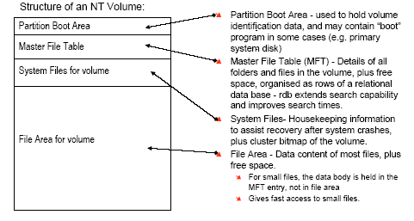

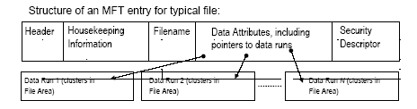

The Data Attributes may contain:
The actual data records for a small file;
For larger files, as in the example above, there are pointers to chains of clusters (data runs) in the File Area of the volume.
For very large files there may be pointers to one, or even two, additional MFT entries containing a header, plus pointers to data runs. (This is similar in concept to indirect blocks in UNIX I-node structures.)

End of Unit - Summary of Achievements

On completion of this unit you should have achieved the following :

On completion of this unit you should:

- Understand the structure and functions of a File Management sub-system.

- Understand and appraise mapping of logical file systems to physical storage.

- Understand the principles of disk storage hardware and how these are used by common operating systems.

